 | PraC-MARENG NEWSLETTER V | 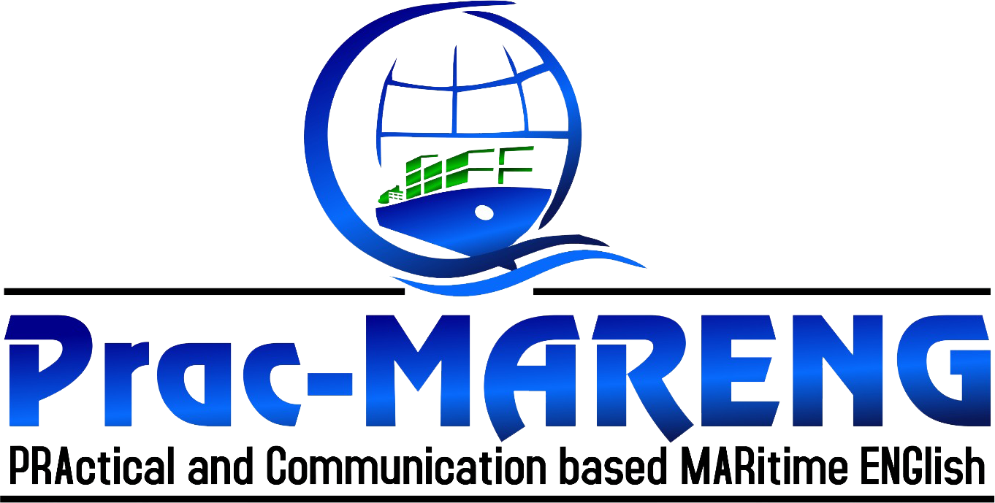
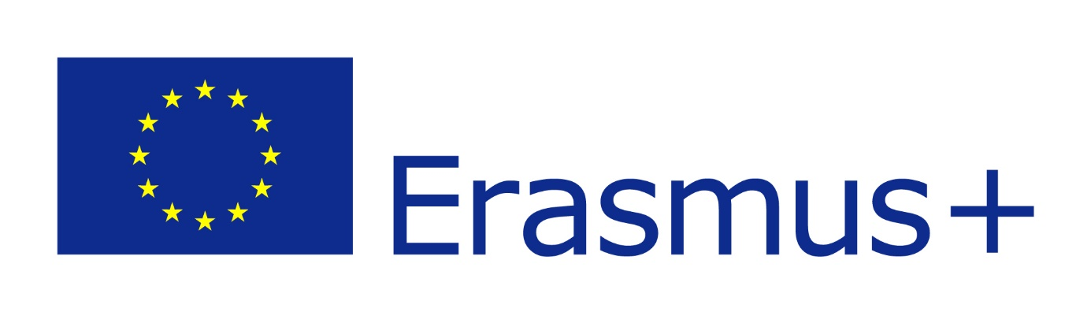
OCTOBER 2021
Issue 5

PRAC-MARENG FINAL CONFERENCE
A distinguished panel of international speakers discussed best practices in Maritime Education and Training, focusing on the future opportunities to improve the quality and standards in MET institutions. The conference was held to improve the current situation and look at the issue from the view of different Maritime professionals, academics, policy makers and international organisations.
The participants entered the building (Sky Center La Marseillaise - 2bis) with a QR code generated due to local COVID-19 requirements. They joined the event by taking into account of social distance, mask and hygiene conditions because of Coronavirus pandemic.
The event was broadcast live via Youtube as well. Online participants watched the conference with the live stream link provided before the conference: https://youtu.be/-lgSO9h2Zh8
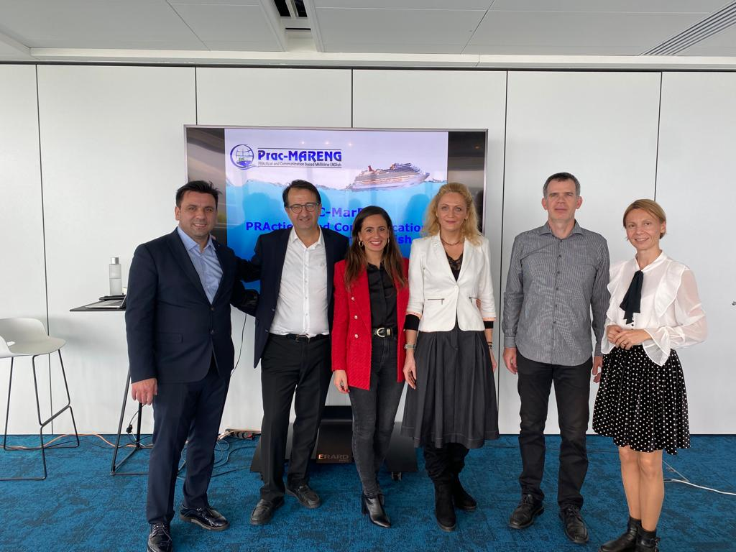
In the event the partners of “the PraC-MARENG Project” were present: LAM France (Lyonel A. Makzume Group of Companies) (FR), Maritime Innovators (Turkey), Spinaker (Slovenia), Constanta Maritime University (Romania) and Lithuanian Maritime Academy and Tuzla District Governorship (Tuzla Kaymakamlığı), Turkey.

On 21st October 2021 the European Conference on Practical Communicative Approach in Maritime English was hosted by the PraC-MARENG partnership in Marseille, France. The partnership is involved in an EU funded project entitled PraC-MARENG (www.prac-mareng.com) to present a platform for the training of seafarers in MARITIME ENGLISH across Europe by enabling practical and communicative approach with the ultimate aim of improving the level of safety at sea worldwide. The partnership organised the multiplier event (final conference) of PraC-MARENG project for the wide range of target groups including seafarers, maritime students, qualification bodies, shipping companies, maritime education providers, maritime Institutes, national governing bodies, maritime union organisations.
The conference targeted academics, maritime professionals, international organisations and policy makers who are interested in working towards improving communication standards at sea. The aim of the conference was to inform local, national and international maritime authorities, organisations and professional bodies about the PraC-MARENG approach, and to interact with MET policymakers, suppliers and end-users to gain feedback for the outputs of the project.

WAS HELD IN MARSEILLE, FRANCE

OCTOBER 2021
Issue 5

PraC-MARENG Conference
The conference started with an opening speech of  Ms. Zeynep Aslan, conference secretary from LAM France. |  |  | PRAC-MARENG PRODUCT
Mr. Stéphane Salvetat, president of LAM France had a welcome speech and talked about the project background and the need for PraC-MARNEG Project. M. Alain Mistre, president of the “Maritime Union Organisation” – UMF got on the stage for a welcome speech and the importance of Maritime English in the sector. Arnoux Mayoly, president of “Lamaneur Association” made a presentation about “MARITIME ENGLISH: The current situation in Language Barriers and its effects on the Maritime Sector”.  Mr. Yalçın Kuzören, project manager from Tuzla District Governorship, Turkey made a presenation about “Research findings on Communicative Barriers and Curriculum Design” online. Dr. Corina Varsami, Associate Professor, Constanta Maritime University gave | comprehensive information about “Content and Assessment Development Approach”. Arvydas Jankauskas from Lithuanian Maritime Academy made a presentation about “Quality Assurance and Control – Internal & External Evaluations”. Tomaz Gregoric, director from Spinaker (Slovenia) presented “Innovative Approach on E-learning and E-assessment”. Last but not least, Mr. Ugurcan Acar, project manager, Maritime Innovators, TR made an extensive presentation about “PraC-MARENG: Introduction of the Product”. The conference went on with Q&A session. The participants asked questions about the conference topic and PraC-MARENG product. The conference ended with the cocktails for evaluation of the conference and networking. |  | 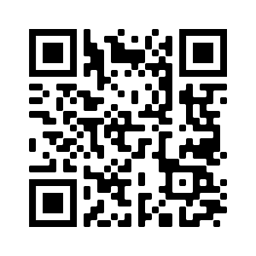  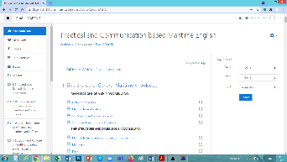  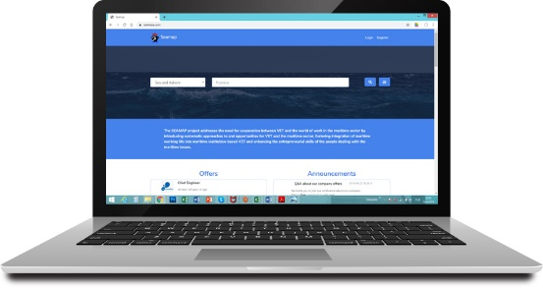  The e-Learning platform has integrated examples of real tasks/activities, such as VHF communications that seafarers are conducting when using current technology. Case-based scenarios in various vessels with real communication situations using SMCP phrases under IMO Model courses: www.prac-mareng.com/e-learning  The assessment tool has been designed to enable users to assess the level of knowledge acquired during the learning phase. It is a software that will have the capability to store, retrieve, handle and present results of the attempt during assessing the practical knowledge of the learner.
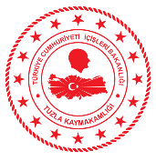  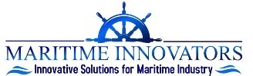  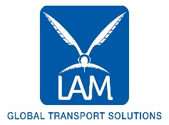  A copy of each publication can be accessed through the news section on the project’s site. Additionally, a project flyer and some other dissemination materials can be downloaded from our site.  The European Commission's support for the production of this publication does not constitute an endorsement of the contents which reflects the views only of the authors, and the Commission cannot be held responsible for any use which may be made of the information contained therein. |  | 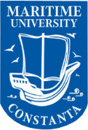  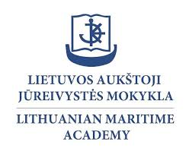  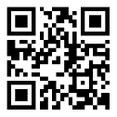  Follow us on social media:  #pracmareng  /PracMarEng  @MarengPrac  www.linkedin.com/in/prac-mareng  More about the project: www.prac-mareng.com
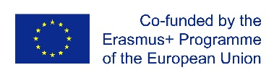
bit.ly/2ZiQE6G

